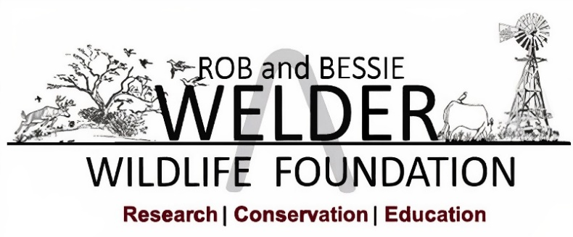

Position Announcement

Conservation Educator

The Rob and Bessie Welder Wildlife Foundation is a nonprofit organization providing wildlife conservation research and education in the context of a working 7,800-acre ranch located in San Patricio County, approximately 7 miles from Sinton, Texas.

The Foundation is seeking an experienced and driven individual who will be an effective leader and teacher of education and outreach programs. The Conservation Educator will serve the Foundation with a personal commitment to awakening a sense of wonder and inspiring environmental stewardship and sustainability through natural science education.
This position will play an integral role in designing, coordinating, and organizing K-12 conservation education programs, classroom activities, teacher workshops, and adult educational programming, including scheduling and arranging tours, field days, community displays, demonstrations and/or meetings for groups interested in natural resources conservation and operations of the WWF. The Conservation Educator will report to and collaborate with the Manager of Education, Outreach, and Curation, and will be expected to begin their position in February 2026.

Qualifications:

• Education
Bachelor’s degree in Natural Resources, Education, Wildlife or
Range Ecology or related field and/or equivalent combination of training and
experience.
- Experience
  - Two years of experience in environmental education; youth program education.
  - Demonstrated experience developing and implementing original educational programming.
  - Thorough knowledge of natural resources, agriculture, and the ability to apply such knowledge to various projects and programs.
- Knowledge
  - Basic knowledge of wildlife ecology and conservation and environmental stewardship.
  - Familiarity with or ability to learn:
    - common South Texas plants, game, and non-game animals, including birds, mammals, herps, and species within Museum exhibits.
    - interpret and educate on benefits of management techniques including rotational grazing, prescribed fire, vegetation control and hunting.

- Skills
  - Effective leadership and supervision of education interns with various learning styles and experience levels.
  - Must possess excellent inter-personal, written, oral communication and public speaking skills.
  - Strong skills in computer software applications including PowerPoint presentations, databases, spreadsheets, word processing and graphic art programs.
- Abilities
  - Must multitask and work both independently and cooperatively with others.
  - Comfortable working with a wide variety of people and situations including staff, volunteers, graduate students, visiting professors/researchers, K-12 grade students, teachers, and the public.
  - Ability to properly operate a variety of standard office equipment including computers and audio-visual equipment.
  - Ability to speak comfortably in front of groups both small and large on topics of natural resource management and conservation.
  - Must be initiative driven, adaptable, collaborative, and innovative and have a positive and integrity driven attitude.
  - Safely operate a 25-seat passenger bus for onsite tours.
  - Willingness to work a flexible schedule, on average 40 hours/week with some nights and weekends.
  - Capable of working in extreme field conditions including extreme temperatures and humidity and often in environments with mosquitoes, ticks, etc.
  - Ability to prepare media releases, informational packets and displays, and plan and present educational programs and workshops.

Essential Duties and Responsibilities:
- Coordinating, scheduling, and leading K-12 conservation education programs, public tours, and other educational and outreach programs.

- Assist with maintenance and curation of the Welder Wildlife Foundation’s Natural History Collections, Museum and Library.

- Assist in ongoing program evaluation and curriculum review, and revision based on Texas Essential Knowledge and Skills Standards.

- Develop or revise summer camp or school outdoor education and field curricula.

- Maintenance of the classrooms, education storage room, vehicles, native plant gardens, trails, etc. as needed.

- Assist with refuge research such as MAPS (Monitoring Avian Productivity and Survivorship) bird banding station, or graduate student research.

- Development of materials for social media, reports, and other materials to support the conservation education program.

- Assist with grant writing.

Salary and Benefits Package: Commensurate with experience. The Foundation offers an exceptional benefit package that includes group medical, prescription, vision, dental and life insurance. Minimum of ten days paid vacation; paid sick leave and 10 paid holidays; 401K plan (including partial employer match).

To apply: Interested and qualified candidates may apply by emailing 1) a cover letter with a statement of interest addressing specific qualifications and 2) resume, as a single PDF file. Provide the names, addresses, phone numbers, and email addresses of at least three (3) professional references. Please email documents or inquiries to:

Angie Arredondo
aarredondo@welderwildlife.org

Application submission will remain open until filled.

WELDER WILDLIFE FOUNDATION IS AN EQUAL OPPORTUNITY EMPLOYER
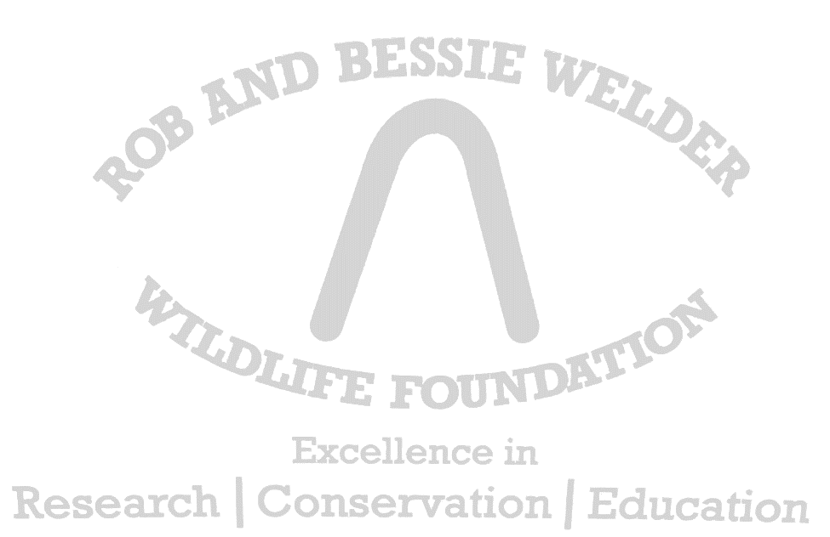
The Welder Wildlife Foundation is an equal opportunity employer which does not discriminate, on or off Foundation property, because of race, color, religion, national origin, gender, sexual orientation, national origin, military status, disability, or age or any other category protected by federal, state, or local law except where age or gender is a bona fide occupational qualification as allowed by the Civil Rights Act of 1964. Employees and students are urged to report any incidents which they believe to be discriminatory to the Chief Executive Officer.

